Chapter 10 – Methods and Arrays

New topics to be covered in class:

- ArrayUtility (using Ex1 methods as examples) - accessing methods in a separate file.
- Returning an array from a method
- Primitive types as argument Vs Array as arguments
- Parallel arrays
- Attempt CodingBat exercises as practice.

Revision of topics:
Methods (call, parameter, argument, return)
Arrays
String
Input from a text file

Exercise 10 – Methods and Arrays
- Modify and improve the code from Moodle as asked below. Make appropriate use of arrays, methods and arguments – with at least one method per question.
- Start with the code in Moodle (which has populated three parallel arrays with data). For each student there is a Name, Programming mark and Web mark
- Test each method thoroughly from main()

- Write a method called displayData() to display all the data neatly as a table.

- Write a method called getStudentAverages() to determine and return the set of average marks for all students.
- Overload displayData() to also include the student average marks in the output.
- Write a method called calculateProgrammingAverage() to determine and return the average mark for the Programming module.
Also determine and display the average mark in the Web module.
- Write a method called countMoreThan60() to determine and return how many students have obtained a mark higher than 60 in programming.
How would you make this method more generally useful?
- Write a method called anyMoreThan90() to determine and return if any student has obtained a mark higher than 90 in programming.
How would you make this method more generally useful?
- Write a method called countNameslongerThan() to determine how many student names are longer than a given length.
- Write a method called anyStudentNameBeginWith() to determine if any student names begin with a particular character.
- Write a method called determineBestStudent() to determine the name of the student that has obtained the highest average mark.
Is there any re-usable code here?
- Write a method to populate the 3 arrays with data from a file.
- Place some of the methods in a separate file and test that you can still call them.

Sample Output

Question 1:
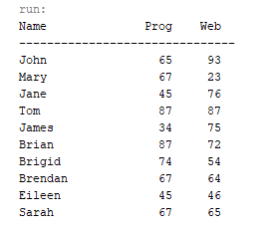

Question 2:
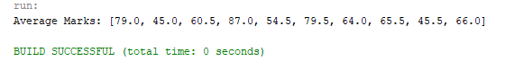
Question 3:

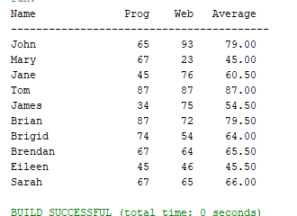

Question 4:
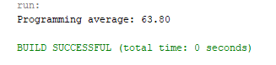

Question 5:
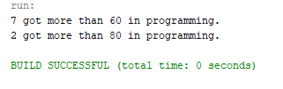

Question 6:

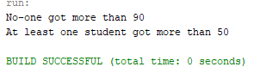

Question 7:
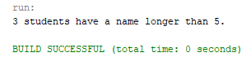

Question 8:
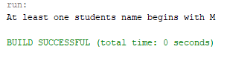

Question 9:
